Guided LAB - 302.1.2 - Hands-on Activity Git and GitHub

# Introduction:

While Git is a tool that's used to manage multiple versions of source code edits that are then transferred to files in a Git repository, GitHub serves as a location for uploading copies of a Git repository.

# Lab Objective:

In this lab, we will demonstrate how to create a local repository for the project using Git, and how to push the project on github from the local repository.

# Learning Objective:

By the end of this lab, learners will be able to use Git and GitHub with the Project.

# Instructions:

## Part 1: Local repository

### Create a local Git repository

When creating a new project on your local machine using Git, you will first create a new repository (or often, 'repo', for short).

To initialize a git repository in the root of the folder, run the [git init](http://git-scm.com/docs/git-init) command.

***git init***

### Create a new file in the repo

Create a new file for the project using any text editor. Let’s just create and save a blank file named newfile.txt.

Once you have created or modified files in a folder containing a git repo, git will notice that the file exists inside the repo. But git will not track the file unless you explicitly tell it to. Git only saves/manages changes to files that it tracks, so we will need to send a command to confirm that yes, we want git to track our new file.

### Add files to the staging area.

To add a file to a commit, you must first add it to the staging area/environment. To do this, you can use the [**git add**](http://git-scm.com/docs/git-add) **<filename>** command.

***git add newfile.txt***

After creating the new file, you can use the [***git status***](http://git-scm.com/docs/git-status) command to see which files Git knows are in existence.

***git status***

***or***

***git log – oneline***

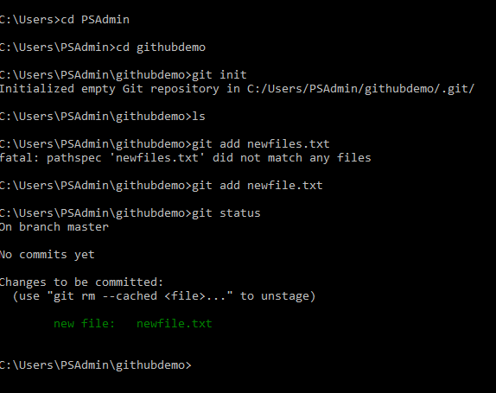

There are several commands that you can choose from. As always, it is important to know what you are staging and committing.

**“git add -A”** stages all files, including new, modified, and deleted files, as well as files in the current directory and in higher directories that still belong to the same git repository.

**“git add .”** adds the entire directory recursively, including files whose names begin with a dot(.).

**“git add -u”** stages new and modified files only; it does NOT stage deleted files.

For more: <https://github.com/git-guides/git-add>

### Create a commit

It is time to create your first commit! Run the command below:

***git commit -m "Your message about the commit"***

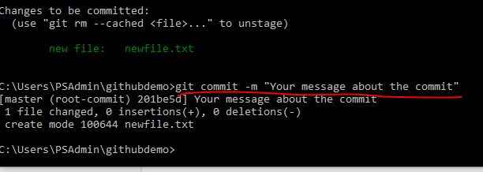

Run the command below to see a **list of all of the commits made to a repository.**

***git log***

### Make changes in newfile.txt

Let's add new content, or some lines in the newfile.txt, and then try to commit new content to the git repository.

***git commit -m "Your 2nd message about the commit"***

***You will get an error if you run the above command because you have to put your file on the staging area first. Then you will be able to run the commit command. To do so, run the below commands:***

***git add newfile.txt***

***git commit -m “Your 2nd message about the commit”***

***Or***

***Git commit -a -m “Your 2nd message about the commit” →*** *This option allows you to skip the staging phase. The addition of* ***-a*** *will automatically stage any files that are already being tracked by Git (changes to files that you have committed before).*

### Create a new branch and switch to a new branch

***git branch my-new-branch // create a new branch***

***git branch // show all list of branches***

***git checkout my-new-branch // switch master branch to new branch***

***git branch // show all list of branches***

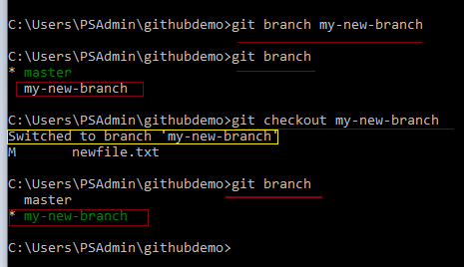

### Make changes in newfile.txt

Let's add new content or some lines in the newfile.txt, and then try to commit new content on the git repository; however, this time, all changes will be saved on the new branch.

***git add newfile.txt***

***git commit -m “add changes in txt file and commit in new branch”***

### Switch back to the master branch.

***git checkout main***

### Merging branches

git merge <branch Name> command is responsible for merging two branch

***git merge my-new-branch***

### Delete newly created branch.

***git branch -d my-new-branch***

## 

## Part 2: Remote Repository

### Create a new repository on GitHub

If you only want to keep track of your code locally, you do not need to use GitHub. But if you want to work with a team, you can use GitHub to collaboratively modify the project's code.

To create a new repo on GitHub, log in and go to the GitHub home page. You can find the **“New repository” option under the “+”** sign next to your profile picture in the top-right corner of the navigation bar:

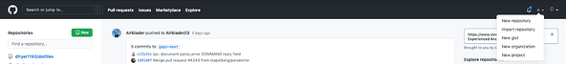

After clicking the button, GitHub will ask you to name your repo and provide a brief description:

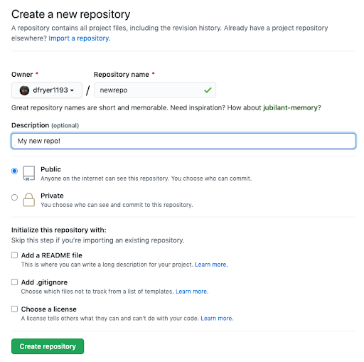

When you finish filling out the information, press the ***'Create repository'*** button to create your new repository.

### Push a branch to GitHub

***git remote add origin*** [***https://github.com/Username/demoforexcercise.git***](https://github.com/haseeb1988/demoforexcercise.git)

***git push -u origin main***

***Username:***

***password***

git remote add origin https://github.com/UserAccountName/demoforexcercise.git -

The above command tells our local repository about a remote repository located somewhere. The location of our remote repository is https://github.com/UserAccountName/demoforexcercise.git. Now, if we want to send our code to GitHub, we can just type in git push https://github.com/UserAccountName/demoforexcercise.git main - but typing that whole URL can be difficult. Instead, it would be better if we could give the URL a nickname (also called an alias) - that is what "origin" is! By setting up the alias, we can simply type git push origin main to send the code from our main branch to this remote repository.

So going back, git remote add is how we tell our local repository about a remote repository (that we can send/retrieve code from). origin is a nickname for where the repository is actually located (at https://github.com/UserAccountName/demoforexcercise.git).  
To see your remotes locally, you can type git remote -v. If you need to remove a remote, you can use git remote rm NAME_OF_REMOTE.

git push -u origin main - Now, we can send our code from a local repository to a remote repository (which we aliased to origin in the previous command). The -u flag allows us in the future to only have to type git push instead of git push origin main.

Let’s review this command: git push is how we send code from a local repository to a remote repository. origin is where we are sending it (specifically to origin/main, which is the master branch of our remote repository). main is the local branch from which we are sending our code.

### Get changes on GitHub back to your computer.

***git pull origin main***

***Or***

***git pull***

# Submission Requirements:

Prior to beginning this guided lab, download a copy for yourself and save to your desktop/laptop, Google Drive, or Microsoft OneDrive. Throughout the lab, you will be required to take screenshots of your progress, and insert the screenshots in the designated areas.

After completing the guided lab, submit your copy of the document on Canvas. You will be prompted to complete a file upload. By uploading the document with the required screenshots, the guided lab can be reviewed by the instructor and marked as completed.

Take a screenshot of the report appearing in the test results, and enter the image below.

|  |
| --- |
|  |

